Introducing In-store Media in a Multiple-Pharmacy Group
March 2021

CASE STUDY
M&B Healthcare

Screen & Display
Information

Pharmacy TV
&
Digital Signage

INTRODUCTION

The M&B Healthcare Group is an 12-branch independent pharmacy group based in North West England. Operating in the heart of local communities, their pharmacies deliver clinical services close to home. Their teams are committed providing the latest healthcare information and advice to patients and consumers.

As part of their ongoing service development, M&B Health wanted to introduce digital screens to ‘modernise’ the way, they engage with patients and other pharmacy users.

Following a detailed options assessment with 9Ways Digital Media, the group owner decided to invest in the Pharmacy TV channel (landscape screens) position in a patient-facing area inside each pharmacy PLUS a digital signage screen (portrait) position in the window to attract passing footfall.

Size of Contract

A total of 14 screens were commissioned from 9Ways Digital Media in a variety of size in both landscape and portrait orientation. TV channel subscription and on-screen media was confirmed for an initial 12-month period with rolling contract thereafter.

The 9Ways technical team worked closely with the client to identify and recommend the correct hardware based on the environment and intended outcomes of each pharmacy in the M&B estate.

Our team worked with third party suppliers of screen stock, mounting brackets/stands and ancillary hardware. However, we ensured our client, M&B Health dealt only with 9Ways and was fully supported by direct contact at all times. Similarly, systems installations in the M&B estate across Lancashire, Merseyside and Yorkshire were fully managed by us.

Participating Pharmacies

- Adel Pharmacy, Adel, Leeds
- Atlas Pharmacy, Fingerpost Park Medical Centre, St Helens
- Fingerpost Pharmacy, Fingerpost, St Helens
- Facer Pharmacy, Hutton, Preston
- Hawkley Pharmacy, Hawkley Hall, Wigan
- Lydiate Pharmacy, Lydiate, Merseyside
- New Springs Pharmacy, Wigan
- St Chads Pharmacy, Oldham
- Suburb Pharmacy, Oldham
- Village Pharmacy, New Longton, Preston

METHODOLOGY

- Completion of site surveys. This is a key part of our process as it sets the plan for the install. A survey was completed for every pharmacy to identify and confirm:

- Screen size
- Screen position, documented with photographs identifying mounting location, any obstructions, pipes, electrical cabling etc
- Distance to power source
- Location of router
- Internet signal test
- Identification of hazards relating to the install e.g restricted operating space for installation engineers
- Proximity of working area to members of public using the pharmacy

- Creation by 9Ways of an installation schedule based on pharmacy location, installation day and time preferred by pharmacy, availability of business owner or delegated representative for sign-off and overall efficiency of install process.

- Using the standard 9Ways screen build and installation process^{(i)} the screens of choice were installed across the M&B estate in accordance with the confirmed schedule.

- On completion of each installation, the business owner or delegated representative person reviewed the quality of workmanship, viewed on-screen content to confirm go-live of each media channel.

- Once installed a sign off sheet identifying system serial numbers together with photographic evidence of the screens in situ was signed off by the business owner or delegated representative to confirm acceptance of complete installation.

- Each pharmacy account was then handed over to our media production team for the ongoing production of media content and day-to-day management of broadcast schedules, both television and digital signage.

^{(i)} Standard Technical build

To reassure customers that on-screen content display will not be interrupted, even in the event of slow internet speeds of total interruption of connectivity, we adopt the following measures:

- A content management system is deployed to all screens, allowing 9Ways to control screen content remotely. This requires a full internet test during every site survey.

- With the M&B Healthcare installs, we were provided with the challenge of some pharmacy branches located in rural areas with slow internet speeds.

- To ensure the uninterrupted screening of media content, media downloading to the screens takes place ‘in the background’ by our engineers. This also ensures:

- no interruption of channel display even if internet connectivity is lost
- no on-screen “buffering” of live content.

OUTCOMES

Customer Testimonial

“We knew we wanted to go digital with our health messaging and marketing strategy but weren’t sure of the best way to go about this. After reviewing the options available in the market, we further engaged with 9Ways Digital Media who created a complete package for our estate.

They took-on the responsibility of doing all the due diligence for each of our pharmacies to identify what would work best on a case-by-case basis. We agreed on the project, set the install dates and the screens were installed as agreed. It really was a seamless process.

As with any project of this size, there’s always a chance something might go wrong! In our case, it was one of the couriers who misplaced a screen but the guys at 9ways were brilliant. They provided immediate updates and gave us a date for the issue to be resolved without us even having to ask!

For us, probably the biggest benefit of working with 9ways -apart from the obvious efficiency and success of the installs- has been the new ideas they’ve brought to us. Managing an estate of pharmacies means you don’t often think about what you should be promoting in each branch but the guys at 9Ways are always presenting new ideas for screen content and coming up with the best ways of presenting our messages on screen.”

Pete Burrows
Managing Director, MB Healthcare Group

IMAGE GALLERY
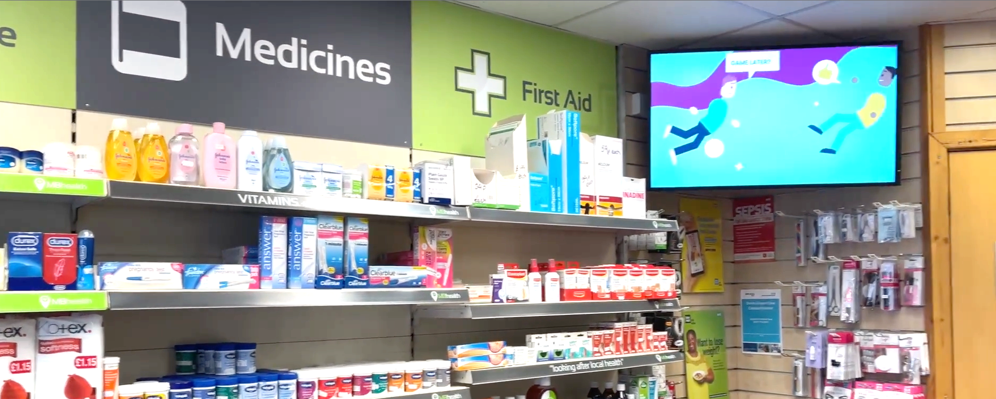
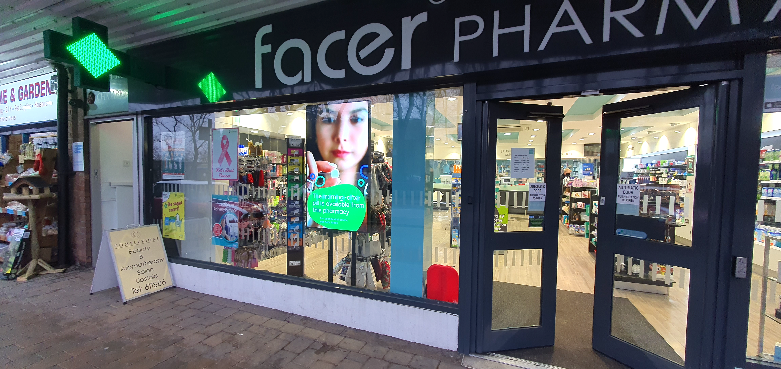
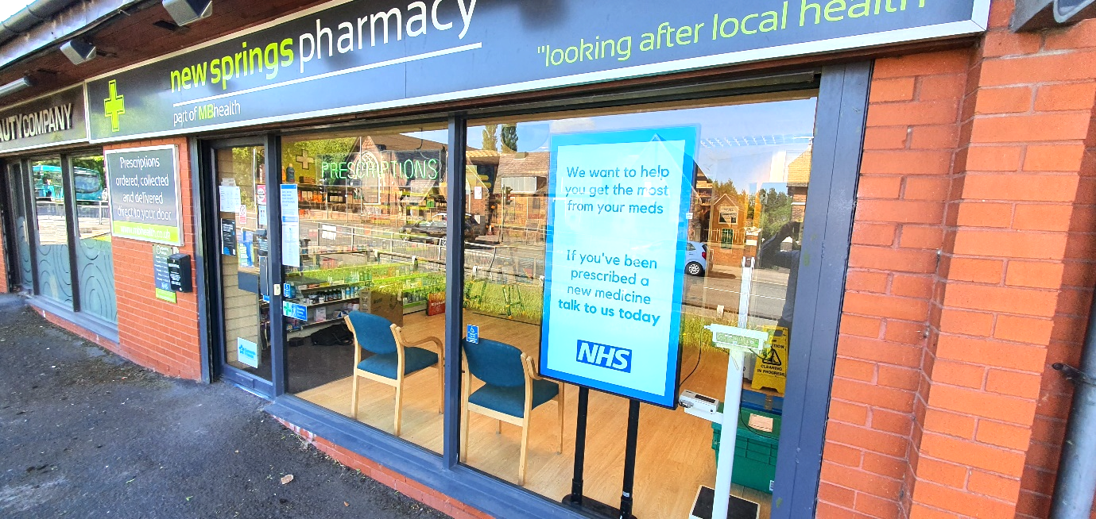
Suburb Pharmacy, Oldham

Facer Pharmacy, Hutton, Preston

New Springs Pharmacy, Wigan

