The impact of digital media on the demand for Covid-19 Lateral Flow Kits
September 2021

CASE STUDY
Knights Tullochs Pharmacy

Screen & Display
Information

Pharmacy TV
&
Digital Signage

INTRODUCTION

A Pharmacy TV channel tailored to customer requirements was installed in Knights Tullochs Pharmacy, Sunderland, In September 2021.

The aim of this case study is to assess patient engagement rates with digital TV channel content when compared to the use of the written materials traditionally available in community pharmacies i.e. posters and leaflets.

To achieve the desired comparison, specific data points were tracked and measured for two comparable pharmacy sites, one with Pharmacy TV installed and the other reliant solely on the use of distributed written leaflets and visual posters.

Participating Pharmacies

- Pharmacy with TV channel: Knights Tullochs Pharmacy, Pennywell Shopping Centre, Sunderland
- Pharmacy with written materials and no media screen: Knights Snowdon Pharmacy, Springwell, Sunderland.

Both pharmacies are situated in a similar geographic area, near to retail shops, with similar consumer demographic and similar footfall signature and volume.

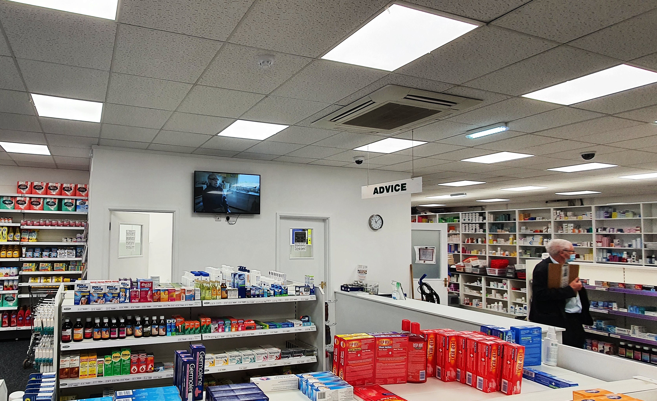
Pharmacy TV in Knights Tullochs Pharmacy
METHODOLOGY (in partnership with Knights Tullochs Pharmacy)

- Completion of site surveys to identify optimal screen size based on available space and budget.

- Using the standard 9Ways screen installation process, a 43-inch Philips android display screen was mounted in full view of patients waiting to collect prescriptions.

- 9Ways created and scheduled on-screen a series of digital assets including full motion graphics designed to promote the lateral flow kit service to patients and customers and short educational films about the value of lateral flow testing. In addition, we screened Public Health campaigns and pandemic advisories.

- We worked with the pharmacy team to identify key measurable data around local public health needs, The distribution of lateral flow kits during the second wave of the Covid-19 outbreak was selected.

- Using service data submitted by the pharmacy through its MYS portal, we were able to track the number of lateral flow kits handed out to patients at Knights Tullochs and Knights Snowdon Pharmacies.

- Data for this new NHS service was sourced for the 5-month period from April to August 2021.

OUTCOMES

Pharmacy Branch | Total LFK distribution  (5-mnths) | Increase in distribution volume | % increase in distribution
Knights Tullochs | 795 | 310 | 63%
Knights Snowdon’s | 485 | 0 | 0
*Data source: MYS Portal

Summary

The above table shows a considerable 63% increase in the distribution of Lateral Flow Kits from Knights Tullochs Pharmacy during the 5 months from April to August 2021.

When taking into consideration the proximity and other similarities in geographic location and footfall between the two pharmacies taking part in the study, the pharmacy owner agreed there was an evident correlation between the large increase in uptake of the service and the use of effective on-screen media.

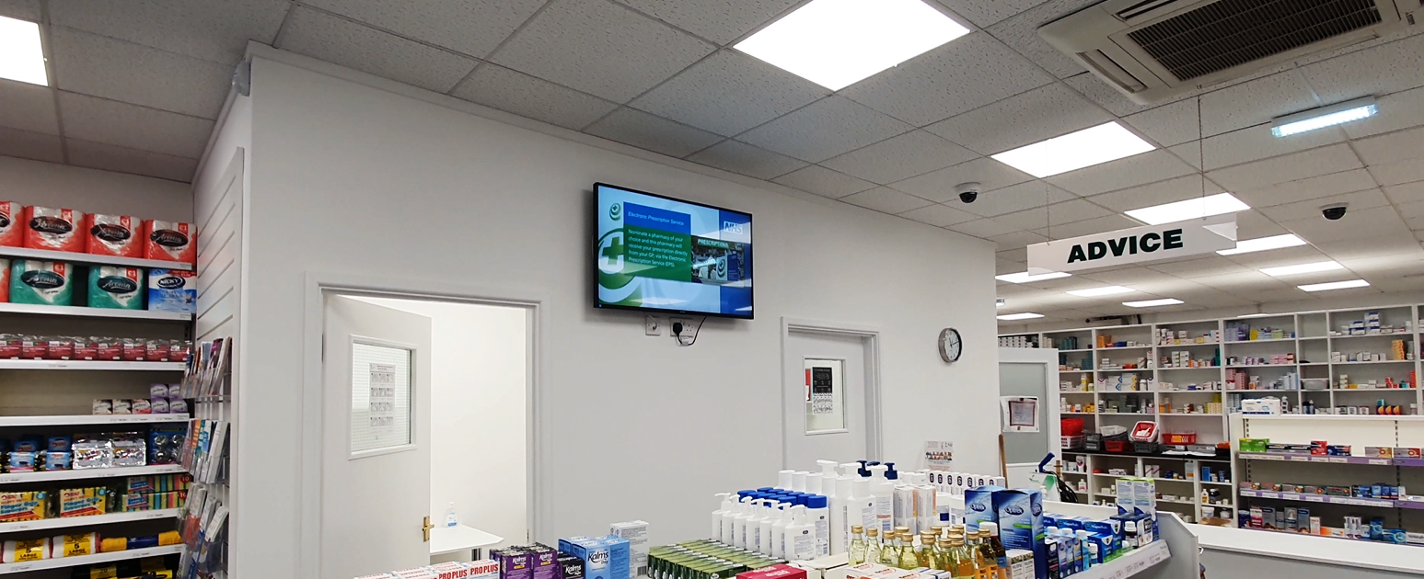

Pharmacy TV in Knights Tullochs Pharmacy

